Recorder Karate

Beginner List
White: Au Claire de la Lune p. 5
Yellow: Suo Gan p. 6
Orange: Merrily We Roll Along p. 6
Green: Wacky Waltz p. 7
Purple: Good News p. 7
Blue: Hop Old Squirrel p. 8
Red: Long Legged Sailor p. 10
Brown: *Lucy Locket
Black: *Who Has Seen the Wind?

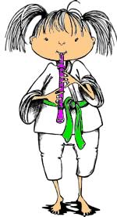

Advanced List
White: *Cotton Eyed Joe
Yellow: *Tom Dooley
Orange: *Hush Little Baby
Green: Hallelujah Chorus p. 12
Purple: Lightly Row p. 14
Blue: Aura Lee p. 15
Red: When the Saints Go Marching p. 16
Brown: Amazing Grace p. 28
Black: Beethoven’s 9th Symphony Theme p. 25

*Songs are on separate page in paper cubby

Earn your recorder lanyard if you can play:
Take Me Out to the Ballgame p. 36
Happy Birthday to You p. 41
Auld Lang Syne p. 42

